 E:\TeachingOldM\Android All\code_examples\androidhtp2_examples\eclipse_projects\FlagQuiz\assets\Asia\Asia-South_Georgia.png L1 FA23

Q1:

Software Requirements Specification

for

Version 1.0 approved

Prepared by

Le Nguyen Hoang Phuc-SE172886

**FPT University Campus Ho Chi Minh**

**Tuesday, November - 14 - 2023**

Q2:

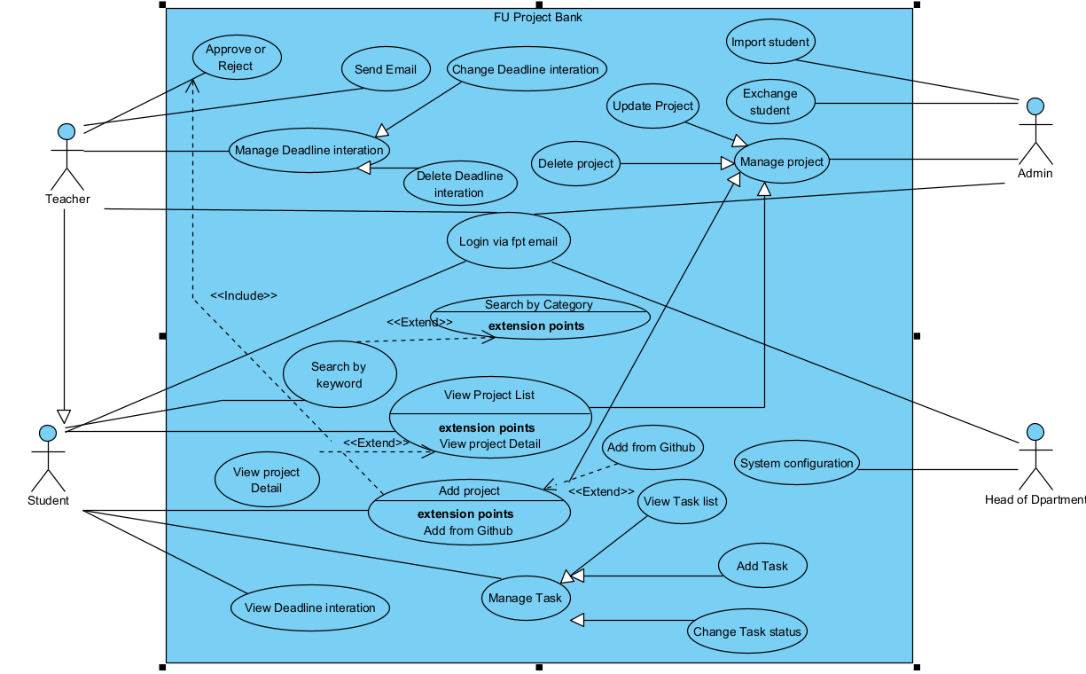

1. In this exam paper, the name of the rectangle is: FU Project Bank

2. The actor may be human, other software systems or devices. In this exam paper, list the name of >= 4 actors is:  
 - Admin  
 - Student  
 - Teacher  
 - Head of Department

3. In this exam paper, list the name of >= 5 use cases are:

3.1 Login via fpt email

3.2 Search by keyword

3.3 View all project

3.4 Add Project

3.5 Change Task status

4. The actors are inside or outside of the rectangle: Outside

5. The ovals represent the use cases are inside or outside of the rectangle: Inside

6. The primary actor of the use case add Project is: Student

7. The secondary actor of the use case add Project: Admin

8.Based on the fact you already used coursera. The use cases in this exam paper may have relationship.

8.a List the name of two use cases that have extend relationship: View Project List, View Project Details

8.b The name of base use case (in 8.a) is: View Project List

8.c The name of extends use case (in 8.a) is:  View Project Details

8.d The dashed line with an arrow that points to which use case:  View Project List

9.   Based on the fact you already used Coursera, the use cases in this exam paper may have relationship.

9.a List the name of two use cases that have include relationship: Add Project, Approve or Reject

9.b The name of based use case (in 9.a) is: Add Project

9.c The name of include use case (in 9s.a) is: Approve or Reject

9.d The dashed line with an arrow that points to which use case?  Approve or Reject

Q3:

|  |  |  |  |
| --- | --- | --- | --- |
| UC ID and Name: | UC-01-Add Project | | |
| Created By: | PhucLNH | Date Created: | 14/11/2023 |
| Primary Actor: | Student | Secondary Actors: | Admin |
| Trigger: | The student indicate to Add Project | | |
| Description: | Students have the ability to utilise the FUPB platform to add their project idea to the system, teacher can review the project and decide to approve or reject this project. | | |
| Preconditions: | PRE1 - Student is logged in FUPB as student role  PRE2 - The project is either stored on the student's local computer or has already been uploaded to GitHub. | | |
| Postconditions: | POST1 - The status of the student Project is Done  POST2 - The teacher is able to access and review the student's project. | | |
| Normal Flow: | **1.0. Submit project from local computer**  1. Student clicks on Add Project button  2. FU Project Bank presents a modal that enables students to choose a specific file path.  3. The student selects the project path (e.g., /D/Phuc/SWP391) and clicks the Confirm button.  4. FU Project Bank displays an alert to the student, asking for confirmation.  5. The student clicks on "Yes."  6. The project is successfully create, then waiting for teacher approve. | | |
| Alternative Flows: | **1.1. Add project from GitHub**  1. Student clicks on Add Project button (see 1.0 E1)  2. FU Project Bank presents a modal that enables students to input a GitHub repository URL.  3. The student enters a URL that points to their project.  4. FU Project Bank will find the repository, then display an alert to the student, asking for confirmation.  5. Return to step 5 of normal flow. | | |
| Exceptions: |  | | |
| Priority: | High | | |
| Frequency of Use: | Usually in use about 1000 times in November especially (7 AM – 10 AM). | | |
| Business Rules: | **BR-1.** The project cannot exceed 10MB. | | |
| Other Information: | The student has the ability to cancel the upload process at any time of their choosing. | | |
| Assumptions: | The student's internet connection remains stable while uploading the file. | | |

**Q4:**

1. Performance:

* **Response Time:** The system should respond to user interactions within 2 seconds.
* **Throughput:** The system should support a minimum of 1000 concurrent Login.
* **Latency:** The system's communication latency between components should not exceed 50 milliseconds.

2. Reliability:

* **Availability:** The system should be available 99.9% of the time.
* **Fault Tolerance:** The system should continue functioning properly even in the presence of hardware or software failures.
* **Recoverability:** The system should be able to recover data and resume normal operation within 1 hour after a failure.